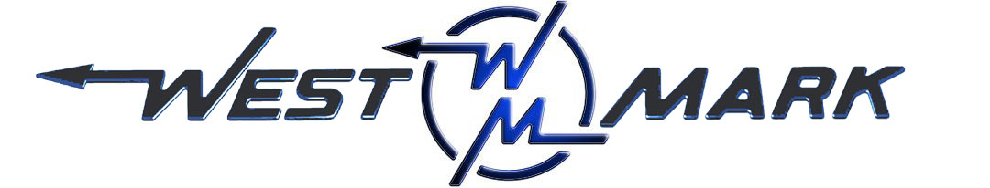
P.O.BOX 100 PHONE: (209) 537-4747
CERES, CA 95307 TOLL FREE: (800) 692-5844
www.west-mark.com FAX: (209) 537-1753

GENERAL

The following equipment shall be a new West-Mark tandem axle semi trailer.

OVERALL LENGTH: Approximately forty-three feet six inches (43' 6").
PRODUCT: Specify _______________________________.
PRODUCT WEIGHT: 8.35 lbs./gallon.
VESSEL CODE: Non-Spec.
TANK OPERATING PRESSURE: Atmosphere.
VACUUM RATING: None (0 in./Hg).
TANK OPERATING TEMPERATURE: 125° F maximum
INTENDED AREA OF OPERATION: Specify _______________________________.
INTENDED USE: Highway only.
TRACTOR
• Tractor, Customer supplied.
TANK/ MANHOLES/ VENTING
• Barrel, 6500 Gallons T-304 stainless steel 12GA round, straight.
• Capacity does not include head outage.
• Heads, 12GA stainless steel, dished and flanged.
• Baffles- NONE. (Available as option upon request)
• Rings, stainless steel channel sections, fully welded to shell (if required).
• Wings and Bolsters, Stainless Steel.
• Side Filler, Stainless steel.
• Weld Finish, interior to be W-2 with all longitudinal seams to be W-3.
Exterior weld finish to be W-2.
• Manhole(s), one (1) 20" stainless steel full opening with
White Hypalon gasket.
• Venting, one (1) double outlet vent.
LADDERS/ WALKWAYS/ SPILLDAMS
• Spilldam- NONE. (Available as option upon request)
• Ladder, one (1) aluminum multi-purpose.
• Walkway, grip tape to be installed rear of manhole.
LIGHTS AND WIRING
• Electrical System 12-volt, 7-way, and vapor proof. Lamps to be L.E.D. and meet all D.O.T. requirements
- Four (4) stop/tail/turn lights in 2-hole, stainless steel boxes; 2 red each side.
- One (1) red 3-light I.D. at rear
- One (1) amber turn/marker light @ center of unit (prox.) each side if required by DOT.
- One (1) amber marker light each side of unit at front.
- One (1) red marker light each side of unit at rear.
• Security Rings / Mount Covers- NONE. (Available as option upon request)
• Reflectors, per D.O.T.
• Conspicuity Striping, per D.O.T.
• Front Receptacle, 7-way nosebox w/ 15 amp circuit breakers.
PLUMBING
• Rear Outlet, stainless steel split pipe to a
3" butterfly valve.
• Plumbing to end in 3" stainless steel male camlock adapter and lockable brass cap with chain.
UNDERCARRIAGE
• Kick Plate, stainless steel.
• King Pin Plate, adjustable carbon steel upper coupler set at a 48" ride height.
• Landing Gear Subframe, stainless steel.
• Landing Leg Support, pipe style.
• Landing Gear, 2-speed steel w/ sand shoes.
• Rear Subframe, stainless steel construction for a tandem axle suspension.
• Suspension, one (1) with cast hangers for tandem axle.
• Spring(s), four (4) 3-leaf medium arch.
• Axle(s), two (2) 71-1/2" track, hub piloted, with auto slack adjusters.
• Outer Wheel(s), four (4) aluminum machined.
• Inner Wheel(s), four (4) aluminum machined.
• Tire(s), eight (8) commercial grade radial.
• Bumper, stainless steel non-code.
• Brake System, to D.O.T. ABS system.
• Rear Fenders, aluminum contour.
• Fender Pipe Mounting, stainless steel with U-bolts and under straps.
• Mudflaps, WHITE, poly, anti-spray type.
MISC.
• Paint, (specify color) all carbon steel fabricated parts.
• One (1) Operation and maintenance manual(s) in paper format and one (1) on CD-ROM complete with:
- Operator & maintenance manual
- Calibration chart (if applicable)
- Equipment parts list
- Misc. vendor literature / manuals
• Theoretical calibration chart shall be supplied
• Vehicle Data Plate(GSA): None.
• Vehicle shall be road tested.

Any and all Brand Name parts mentioned in specifications above are subject to substitution of an equal part that is of a different brand. Other substitutions may also be made if said substitution does not affect the intended function of the vehicle’s mission and is equivalent or an upgrade as determined by West-Mark. All specified dimensions are nominal and may vary slightly.

Warranty, unit shall be free from defects in material and workmanship for a period of ONE (1) year.

F.O.B.:
West-Mark (CAGE: 880W5)
581 Industry Way
Atwater, CA 95301. (F.O.B. destination available as option upon request.)

