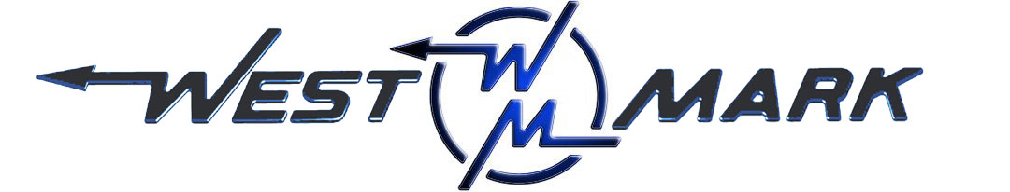
P.O.BOX 100 PHONE: (209) 537-4747
CERES, CA 95307 TOLL FREE: (800) 692-5844
www.west-mark.com FAX: (209) 537-1753

GENERAL

The following equipment shall be a new West-Mark Dump Truck.

INTENDED AREA OF OPERATION: Specify _______________________________.
INTENDED USE: Highway and Unimproved roads.
CHASSIS
New Freightliner model M2 106 conventional cab, 2-door chassis:
DRIVE: 6 X 4
GVWR: 58,000 lbs
Front Axle: 18,000 lbs Capacity
Rear Axles: 40,000 lbs Capacity, Beam Suspension
Engine: Cummins ISL 300 HP and 860 lb/ft torque
Transmission: Eaton® Fuller® 10-Speed FRO-14210C manual

• Left-hand drive
• Cab color to be White
• Battery disconnect switch
• Maintenance free batteries
• Remote mounted positive & negative posts for jumpstart
• Vertical tailpipe mounted at RH side
• Coolant rated to -34F
• Engine block heater
• Quick disconnect fitting with tire inflation kit.
• Front tow hooks, eye(s), or pin (application varies based GVWR)
• LH and RH grab handles
• Air horn
• Electric horn(s)
• Daytime running lights
• LH and RH convex mirrors mounted under primary mirrors
• Heater, defroster, and air conditioner
• One (1) each 12V power supply in dash
• Speedometer/Odometer capable of displaying in both miles and kilometer, with trip and hour meter.
• Adjustable tilt and telescoping steering column
• Back-up alarm
• AM/FM/WB radio with Bluetooth and Auxiliary inputs
• Fuel capacity 50 gallons
• Cab suspension - Air Ride
• Air driver and fixed passenger seats
• Heated mirrors (flat and convex)
• Heated fuel/water separator
• Mud and snow tires on rear axle(s)
• Steel wheels
• Towing extended/roadside service warranty, 1 year/unlimited miles/km, $550 cap (U.S. Domestic only)

DUMP BODY
• 12/15 Yard Semi-Elliptical Dump Body, approximately 16 feet long, made from AR400 with a dump angle
of approximately 45 degrees.
• Front Wall, Heavy Duty
• Air-Latch, tail gate with vertical braces.
• Hi-Lift Tailgate- NONE. (Available as option upon request)
• Front Mount Hoist, telescopic with dog house.
• Hydraulic Cylinder, w/ greaseable pins.
• Sub frame, w/ heavy duty cross members.
• Fenders, full length.
• Cab guard.
• Spreader apron (AR400 material).

• Tarp- NONE. (Available as option upon request)
• Hinges, rear heavy duty with greasable and removable pins.

• PTO, w/ direct mount heavy duty hydraulic pump.
• Controls, between seats for easy access.
• Hydraulic Reservoir, w/ shut-off valves, oil filter and vented cap.
• Mud flaps, black rubber.
• Hitch, Rear butt plate with pintle hook, 7-way electric socket (SAE J560), and 2 D-rings.
• Electric Brake, controller in cab and 7-way RV socket at rear- NONE. (Available as option upon
request)
• Safety Prop, body up.
• Indicator Light, body up .
• Lighting, L.E.D. per D.O.T.
• Reflectors, per D.O.T.
• Conspicuity Striping, per D.O.T.
• Beacon(s)- NONE. (Available as option upon request)
• Load/work light(s)- NONE. (Available as option upon request)
• Paint, body sandblasted, primer coated and painted to match cab with urethane paint.
MISC.
• Document Holder- None. (Available as option upon request)
• Operator Training Guide in each manual containing detailed operating instructions of all functions with photos.
• One (1) operation and maintenance manual(s) in paper format and one (1) on CD ROM complete with:
- Operator & Maintenance Manual
- Calibration Chart (if Applicable)
- Equipment Parts List
- Misc. Vendor Literature / Manuals
• RFID Tag- NONE. (Available as option upon request)
• Vehicle Data Plate(GSA): None.
• Vehicle shall be road tested

Any and all Brand Name parts mentioned in specifications above are subject to substitution of an equal part that is of a different brand. Other substitutions may also be made if said substitution does not affect the intended function of the vehicle’s mission and is equivalent or an upgrade as determined by West-Mark. All specified dimensions are nominal and may vary slightly.

Warranty, unit shall be free from defects in material and workmanship for a period of ONE (1) year.

F.O.B.:
West-Mark (CAGE: 880W5)
581 Industry Way
Atwater, CA 95301. (F.O.B. destination available as option upon request.)

