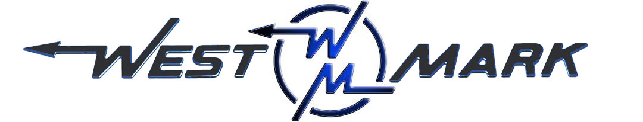
P.O.BOX 100 PHONE: (209) 537-4747
CERES, CA 95307 TOLL FREE: (800) 692-5844
www.west-mark.com FAX: (209) 537-1753

GENERAL

The following equipment shall be a new West-Mark 2-axle, tank truck for fish.

PRODUCT: Live fish.
VESSEL CODE: Non-Spec.
TANK OPERATING PRESSURE: Atmosphere.
TANK OPERATING TEMPERATURE: 125° F maximum
INTENDED AREA OF OPERATION: Specify _______________________________.
INTENDED USE: Highway and gravel roads.
CHASSIS
New Freightliner model M2 106 conventional cab, 2-door chassis:
BRAKES: Air type
DRIVE: 4 X 2
GVWR: 33,000 lbs
Front Axle: 12,000 lbs Capacity
Rear Axle: 21,000 lbs Capacity, Spring Suspension
Engine: Cummins ISB 250 HP and 660 lb/ft torque
Transmission: Allison 3500 RDS automatic

• Cab color to be White
• Maintenance free batteries
• Remote mounted positive & negative posts for jumpstart
• Vertical tailpipe mounted at RH side
• Coolant rated to -34F
• Engine block heater
• Quick disconnect fitting with tire inflation kit.
• Front tow hooks, eye(s), or pin (application varies based GVWR)
• LH and RH grab handles
• Air horn
• Electric horn(s)
• Daytime running lights
• LH and RH convex mirrors mounted under primary mirrors
• Heater, defroster, and air conditioner
• One (1) each 12V power supply in dash
• Speedometer/Odometer capable of displaying in both miles and kilometer, with trip and hour meter.
• Adjustable tilt and telescoping steering column
• Back-up alarm
• AM/FM/WB radio with Bluetooth and Auxiliary inputs
• Towing extended/roadside service warranty, 1 year/unlimited miles/km, $550 cap (U.S. Domestic only)

• Air driver and fixed passenger seats
• Heated mirrors (flat and convex)
• Heated fuel/water separator
• Mud and snow tires on rear axle(s)
• Steel wheels
TANK/ MANHOLES/ VENTING
• Barrel, 1,500 gallons stainless steel 12GA rectangular conical oval
• Heads, two (2) stainless steel dished and flanged.
• Baffles, two (2) stainless steel dished and flanged
• Side Filler Tank Frame, Stainless steel full length frame.
• Bolsters/wings, Stainless steel.
• Top Structure, two (2) channel rings on the exterior
• Tank Mounting, spring loaded.
• Weld Finish, interior to be W-2 with all longitudinal seams to be W-3.
Exterior weld finish to be W-2.
• Manhole(s), one (1) 38" stainless steel full opening.
• Venting, two (2) with shutoff ball assembly.
• Sight Tube(s), two (2) glass.
LADDERS/ WALKWAYS/ SPILLDAMS
• Walkway, aluminum non-slip platform at two (2) side(s) full length above fenders.
• Grab Rail, stainless steel at two (2) side(s), top of tank.
LIGHTS AND WIRING
• Lights, L.E.D. per D.O.T. on body
• Reflectors, per D.O.T.
• Conspicuity Striping, per D.O.T.
PLUMBING
• Overfill / Antisiphon, stainless steel pipe recessed into top of tank with perforated screen.
• Adult Fish Outlet, stainless steel, air operated gate valve.
• Juvenile Outlet, one (1) aluminum camlock adapter and cap.
• Drain Valve, one (1) ball valve with camlock adapter and cap.
• Aeration, three (3) 4" QQ960S 12 VDC clamp style top port aerators with gaskets to prevent leaking while loading fish. Each aerator shall have a 3 prong electric plug to an electric junction box and shall have individual switches that are located in the dash of the chassis.
• Diffusers, six (6) low profile.
• Oxygen Controls, six (6) flow valves
• Oxygen Monitor- NONE. (Available as option upon request)
• Bottle Rack, carbon steel fabricated horizontal.
FENDERS / BUMPERS / ETC.
• Bumper, carbon steel non-code with rope step and gripstrut platform each side.
• Rear Fenders, aluminum contour.
• Mudflaps, black rubber.
MISC.
• Paint, on all carbon steel fabricated parts.
• One (1) operation and maintenance manual(s) in paper format and one (1) on CD ROM complete with:
- Operator & Maintenance Manual
- Calibration Chart (if Applicable)
- Equipment Parts List
- Misc. Vendor Literature / Manuals
- One (1) Set(s) manuals in PAPER format.
• Theoretical calibration chart shall be supplied
• Power Cord, one (1) for use w/ chassis engine block heater.
• Vehicle shall be road tested

Any and all Brand Name parts mentioned in specifications above are subject to substitution of an equal part that is of a different brand. Other substitutions may also be made if said substitution does not affect the intended function of the vehicle’s mission and is equivalent or an upgrade as determined by West-Mark. All specified dimensions are nominal and may vary slightly.

F.O.B.:
West-Mark (CAGE: 880W5)
581 Industry Way
Atwater, CA 95301. (F.O.B. destination available as option upon request.)

