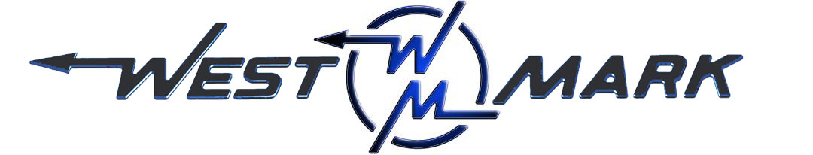
P.O.BOX 100 PHONE: (209) 537-4747
CERES, CA 95307 TOLL FREE: (800) 692-5844
www.west-mark.com FAX: (209) 537-1753

• GENERAL: Severe Service Trailer for off-road transportation of potable water.
• Quality, unit shall be new and unused.
• INTENDED AREA OF OPERATION: Export.
INTENDED USE: Highway and Off-Road.
• Tank, 400 gallons capacity straight barrel.
• Manhole, one (1) 20" stainless steel.
• Venting, one (1)
• Tank mounting, spring type
• Tank Insulation, and jacketing wrapped the entire length of the barrel.
• Tank Cleanout, one (1) 1-1/2" bottom of the tank.
• Sight Gauge- NONE. (Available as option upon request)
• Passivation- NONE. (Available as option upon request)
• Wiring, adequate size to carry the necessary load.
• Intravehicular, 7-way pin style connection.
• Stop/Tail/Turn Lights, L.E.D.
• Reflectors, to meet SAE J594 standards.
• Front Outlet, one (1) valve
• Right Side Outlet Assembly, Two (2) discharges plumbed to front outlet manifold and located inside of a lockable enclosure.
• Left Side Outlet Assembly, Two (2) discharges plumbed to front outlet manifold and located inside of a lockable enclosure.
• Camlock adapter with cap centered between the left side discharge valves.
• Rear Outlet Assembly, One (1) faucet rear of trailer.
• Trailer, 8,000 LB GVWR
• Frame Rails, Corrosion resistant steel frame
• Safety chains, two (2) Safety chains
• Fenders, two (2), with mud splash-back plate
• Dolly Jack, retractable with wheel.
• Hitch, Lunette eye.
• Suspension,
- Axle(s), one (1) Heavy duty wall axle
- Wheel Ends, two (2) stud x BC hubs
- Springs, two (2) Sealed torsion type, high profile
- Shocks, to reduce rebound.
• Mud flaps, shall be provided.
• Brake System, electrically activated.
• Parking Brake- NONE. (Available as option upon request)
• Tire/Wheel Assemblies, two (2) tires mounted to steel wheels painted to match unit.
• Run Flats- NONE. (Available as option upon request)
• SPARE TIRE AND WHEEL: None. (Available as option upon request)
• Spare Tire Mount- NONE. (Available as option upon request)
• Jerry Can and Mount- NONE. (Available as option upon request)
• Chock Blocks- NONE. (Available as option upon request)
• Padlocks- NONE. (Available as option upon request)
• Cabinets(s)- NONE. (Available as option upon request)
• Jack/Tire Tool- NONE. (Available as option upon request)
• Heater- NONE. (Available as option upon request)
• Water Purifier- NONE. (Available as option upon request)
• Helicopter Lift Provisions- NONE. (Available as option upon request)
• C.I.P. Connection- NONE. (Available as option upon request)
• Paint, chemical agent resistant coating (CARC). LUSTERLESS OLIVE DRAB GREEN.
• TANK IDENTIFICATION STENCILS: 4" black stencil "POTABLE WATER", 2" black stencil to determine capacity.
• One (1) Operation and maintenance manual(s) in paper format and one (1) on CD-ROM complete with:
- Operator & maintenance manual
- Calibration chart (if applicable)
- Equipment parts list
- Misc. vendor literature / manuals
• RFID Tag- NONE. (Available as option upon request)
• Data plates permanently marked, non-corroding, UV-resistant, metal material.
• Data Plates shall include the following information:
- Shipping weight
- Overall height, width, and length
- Landing gear and axle loads
- Tie down information
- Vehicle Nomenclature
- Manufacturer's Model Number
- Vehicle Identification (serial) Number or VIN
- Manufacturer's address and phone number
- Date of Manufacture
- National Stock Number (if available)
- Contract Number (if available)
- Data Plate to inform about all lubrication fittings, components, identify the type and grade.
• Operator Training Guide in each manual containing detailed operating instructions of all functions with photos.
• Testing and QC, final Inspection performed prior to, and in preparation of a customer/gov inspection.
• Road test, vehicle shall be tested by factory.

Any and all Brand Name parts mentioned in specifications above are subject to substitution of an equal part that is of a different brand. Other substitutions may also be made if said substitution does not affect the intended function of the vehicle’s mission and is equivalent or an upgrade as determined by West-Mark. All specified dimensions are nominal and may vary slightly.

F.O.B.:
West-Mark (CAGE: 880W5)
581 Industry Way
Atwater, CA 95301. (F.O.B. destination available as option upon request.)

