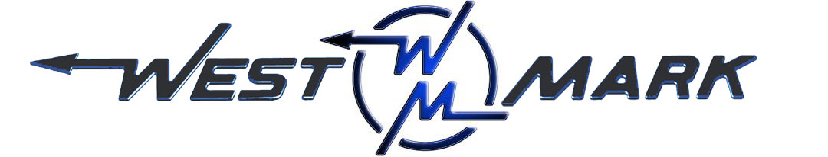
P.O.BOX 100 PHONE: (209) 537-4747
CERES, CA 95307 TOLL FREE: (800) 692-5844
www.west-mark.com FAX: (209) 537-1753

GENERAL
The following equipment shall be a new dust control tank truck.

PRODUCT: Non-potable water.
PRODUCT WEIGHT: 8.35 lbs./gallon.
VESSEL CODE: Non-Spec.
TANK OPERATING PRESSURE: Atmosphere.
TANK OPERATING TEMPERATURE: 125° F maximum
INTENDED AREA OF OPERATION: Specify _______________________________.
INTENDED USE: Highway and Unimproved roads.

CHASSIS
New Freightliner model M2 106 conventional cab, 2-door chassis:
BRAKES: Air type
DRIVE: 4 X 2
GVWR: 33,000 lbs
Front Axle: 12,000 lbs Capacity
Rear Axle: 21,000 lbs Capacity, Spring Suspension
Engine: Cummins ISB 250 HP and 660 lb/ft torque
Transmission: Allison 3500 RDS automatic

• Cab color to be White
• Battery disconnect switch
• Maintenance free batteries
• Remote mounted positive & negative posts for jumpstart
• Vertical tailpipe mounted at RH side
• Coolant rated to -34F
• Engine block heater
• Quick disconnect fitting with tire inflation kit.
• Front tow hooks, eye(s), or pin (application varies based GVWR)
• LH and RH grab handles
• Air horn
• Electric horn(s)
• Daytime running lights
• LH and RH convex mirrors mounted under primary mirrors
• Heater, defroster, and air conditioner
• One (1) each 12V power supply in dash
• Speedometer/Odometer capable of displaying in both miles and kilometer, with trip and hour meter.
• Adjustable tilt and telescoping steering column
• Back-up alarm
• AM/FM/WB radio with Bluetooth and Auxiliary inputs
• Cab suspension - Air Ride
• Air driver and fixed passenger seats
• Heated mirrors (flat and convex)
• Heated fuel/water separator
• Mud and snow tires on rear axle(s)
• Steel wheels
• Towing extended/roadside service warranty, 1 year/unlimited miles/km, $550 cap (U.S. Domestic only)

BODY
• 2,000 Gallon Non-Potable water painted steel tank.
• Heads, 3/16" A36
• Baffle(s) 3/16" A36.
• Baffle(s), Longitudinal 3/16" A36
• U-shaped subframe.
• Doubler plate, 3/16" A36
• Rubber pads between tank and frame.
• Tank Mounts, four (4).
• Manway, 24" circular
• Vortex Breaker, plate w/ screen
• Hydrant Fill, 2.5" w/ swivel swing spout
• Sight Gauge(s), two (2); one at rear and one at front w/ shut-offs.
• Ladder, one (1) rear mounted w/ handrails.
• Fenders, two (2) bonnet style tandem axle.
• Walkway, non-skid top of tank.
• Light Kit, D.O.T. L.E.D.
• Conspicuity tape, D.O.T.
• Mud flaps, rear mounted.
• Paint, tank to be WHITE to match cab.
• Pump, water 750 gpm rated.
• PTO, air shift
• Driveline, 1000 series PTO shaft
• Controls, PTO Cab mounted.
• Pump plumbing, carbon steel.
• All plumbing components welded with groove couplers.
• Distribution manifold.
• Air valves for spray heads cab controlled
• Front Sprayers, two (2) with adjustable fan heads.
• Rear Sprayers, two (2) with adjustable fan heads.
• Side spray left hand side, duck bill with manual up/down operation
• Discharge, 1.5" ball valve driver's side.
• Control Switches, cab mounted.
• Rear in-frame storage area with lid.
• Bumper, rear per D.O.T.
• Paint, frame and plumbing components painted BLACK.
• Low point drains installed in all plumbing.

Warranty, unit shall be free from defects in material and workmanship for a period of ONE (1) year.

FOB: Phoenix, AZ

