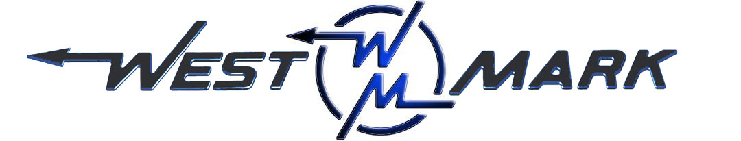
P.O.BOX 100 PHONE: (209) 537-4747
CERES, CA 95307 TOLL FREE: (800) 692-5844
www.west-mark.com FAX: (209) 537-1753

GENERAL

The following equipment shall be a new West-Mark dust control tank truck.

PRODUCT: Non-potable water.
PRODUCT WEIGHT: 8.35 lbs./gallon.
VESSEL CODE: Non-Spec.
TANK OPERATING PRESSURE: Atmosphere.
TANK OPERATING TEMPERATURE: 125° F maximum
INTENDED AREA OF OPERATION: Specify _______________________________.
INTENDED USE: Highway and Unimproved roads.
CHASSIS
New Freightliner model M2 106 conventional cab, 2-door chassis:
BRAKES: Air type
DRIVE: 4 X 2
GVWR: 33,000 lbs
Front Axle: 12,000 lbs Capacity
Rear Axle: 21,000 lbs Capacity, Spring Suspension
Engine: Cummins ISB 250 HP and 660 lb/ft torque
Transmission: Allison 3500 RDS automatic

• Cab color to be White
• Battery disconnect switch
• Maintenance free batteries
• Remote mounted positive & negative posts for jumpstart
• Vertical tailpipe mounted at RH side
• Coolant rated to -34F
• Engine block heater
• Quick disconnect fitting with tire inflation kit.
• Front tow hooks, eye(s), or pin (application varies based GVWR)
• LH and RH grab handles
• Air horn
• Electric horn(s)
• Daytime running lights
• LH and RH convex mirrors mounted under primary mirrors
• Heater, defroster, and air conditioner
• One (1) each 12V power supply in dash
• Speedometer/Odometer capable of displaying in both miles and kilometer, with trip and hour meter.
• Adjustable tilt and telescoping steering column
• Back-up alarm
• AM/FM/WB radio with Bluetooth and Auxiliary inputs
• Cab suspension - Air Ride
• Air driver and fixed passenger seats
• Heated mirrors (flat and convex)
• Heated fuel/water separator
• Mud and snow tires on rear axle(s)
• Steel wheels
TANK/ MANHOLES/ VENTING
• Barrel, 2000 gallons T-304 stainless steel 10GA rectangular oval.
• Heads, 10GA stainless steel, dished and flanged.
• Baffle(s), one (1) 10GA stainless steel, dished and flanged.
• Wings, Bolsters, and Z-Rail, Stainless Steel.
• Tank Mounting, spring loaded.
• Weld Finish, interior to be W-2 with all longitudinal seams to be W-3.
Exterior weld finish to be W-2.
• Manhole(s), one (1) 20" neck ring.
LADDERS/ WALKWAYS/ SPILLDAMS
• Walkway, non-skid tape from ladder to manhole.
• Ladder, aluminum at the rear of the unit.
LIGHTS AND WIRING
• Lights, L.E.D. per D.O.T. on body
• Reflectors, per D.O.T.
• Conspicuity Striping, per D.O.T.
PLUMBING
• Top Fill, one (1) 2-1/2" stainless steel air-gap.
• Fill Connection, one (1) 2-1/2" Bronze Female swivel at end of NST fitting with plug and chain.
• Direct drive PTO "HOT SHIFT" w/ provisions to protect the PTO from overspeed.
• A drive line shall be connected from the PTO to the pump.
• Pump, one (1)centrifugal rated at 650 GPM (minimum).
• Pump Inlet Plumbing, 4" tank to pump carbon steel plumbing.
• Anti-vortex at outlet to pump.
• Discharge Plumbing, to a carbon steel manifold.
• Tank Return, with ball valve on discharge side of the pump.
• Rear Spray Head Package, two (2) fully adjustable grooved nozzle spray heads on a carbon steel distribution bar,
• Discharge End Caps, two (2) carbon steel in plumbing manifold to plug off each un-used connection(s).
• Discharge/sidespray easily added by removing solid cap and clamping on option at end(s).
• Low Point Drains, in all plumbing.
• Controls, switches for P.T.O., spray heads, worklights, and other functions.
FENDERS / BUMPERS / ETC.
• Push Bar at Rear- NONE. (Available as option upon request)
• Bumper, carbon steel box tubing.
• Fender Skirting, stainless steel
• Mudflaps, black rubber.
MISC.
• Paint, on all carbon steel fabricated parts.
• Decals shall be installed on each side of water tank:
• 4" Decals to read: "NON POTABLE WATER".
• 2" Decals to read: "______ GALLONS"
• One (1) operation and maintenance manual(s) in paper format and one (1) on CD ROM complete with:
- Operator & Maintenance Manual
- Calibration Chart (if Applicable)
- Equipment Parts List
- Misc. Vendor Literature / Manuals
• Theoretical calibration chart shall be supplied
• Vehicle shall be road tested

Any and all Brand Name parts mentioned in specifications above are subject to substitution of an equal part that is of a different brand. Other substitutions may also be made if said substitution does not affect the intended function of the vehicle’s mission and is equivalent or an upgrade as determined by West-Mark. All specified dimensions are nominal and may vary slightly.

F.O.B.:
West-Mark (CAGE: 880W5)
581 Industry Way
Atwater, CA 95301. (F.O.B. destination available as option upon request.)

