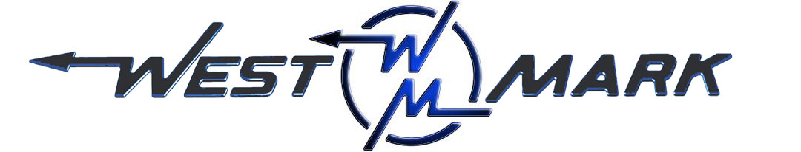
P.O.BOX 100 PHONE: (209) 537-4747
CERES, CA 95307 TOLL FREE: (800) 692-5844
www.west-mark.com FAX: (209) 537-1753

GENERAL

The following equipment shall be a new West-Mark tandem-axle water trailer.

PRODUCT: Non-potable water.
PRODUCT WEIGHT: 8.35 lbs./gallon.
VESSEL CODE: Non-Spec.
TANK OPERATING PRESSURE: Atmosphere.
TANK OPERATING TEMPERATURE: 125° F maximum
INTENDED AREA OF OPERATION: Specify _______________________________.
INTENDED USE: Highway and Off-Road.
TANK/ MANHOLES/ VENTING
• Barrel, 2000 gallon elliptical leg tank.
• Venting, one (1) vent.
• Tank mounted direct to trailer decking.
LIGHTS AND WIRING
• Trailer Lighting, L.E.D. lighting to meet all D.O.T. requirements w/ rear license plate lamp.
-Seven-way male RV type.
-One (1) female RV type socket.
• Reflectors, per D.O.T.
• Conspicuity Striping, per D.O.T.
PLUMBING
• One (1) valve to camlock adapter and lockable cap with chain.
• Trailer, 24,000 LB GVWR tandem axle trailer
• Frame, heavy duty channel style
• Tow Bar, ridged and extend to minimize the threat of early jackknifing at any turning angle.
• Decking, carbon steel diamond plate.
• Dolly Jack, one (1) heavy duty landing gear assembly.
• Axles, two (2) 12,000 lb. 3” round with electric brakes.
• Springs, four (4) each multi-leaf
• Wheel(s), eight (8) steel
• Wheels remain the Factory color as per the manufacturer’s standard.
• Tire(s), eight (8) commercial grade radial.
• Brake System, electric brakes for a tandem axle trailer.
• Break-Away Kit, An electric brake, kit consisting of a break-away switch, trickle charger, and a battery
• Bumper, carbon steel end cap.
• Hitch, one (1) Lunette eye with multi-height adjustability.
• Safety Chain, two (2) with hook.
OPTIONAL ITEMS
MISC.
• Paint, all carbon steel fabricated parts.
• One (1) Operation and maintenance manual(s) in paper format and one (1) on CD-ROM complete with:
- Operator & maintenance manual
- Calibration chart (if applicable)
- Equipment parts list
- Misc. vendor literature / manuals
• Data plates permanently marked, non-corroding, UV-resistant, metal material.
• Data Plates shall include the following information:
- Shipping weight
- Overall height, width, and length
- Landing gear and axle loads
- Tie down information
- Vehicle Nomenclature
- Manufacturer's Model Number
- Vehicle Identification (serial) Number or VIN
- Manufacturer's address and phone number
- Date of Manufacture
- National Stock Number (if available)
- Contract Number (if available)
- Data Plate to inform about all lubrication fittings, components, identify the type and grade.
• Road test, vehicle shall be tested by factory.

Any and all Brand Name parts mentioned in specifications above are subject to substitution of an equal part that is of a different brand. Other substitutions may also be made if said substitution does not affect the intended function of the vehicle’s mission and is equivalent or an upgrade as determined by West-Mark. All specified dimensions are nominal and may vary slightly.

Warranty, unit shall be free from defects in material and workmanship for a period of ONE (1) year.

F.O.B.:
West-Mark (CAGE: 880W5)
581 Industry Way
Atwater, CA 95301. (F.O.B. destination available as option upon request.)

