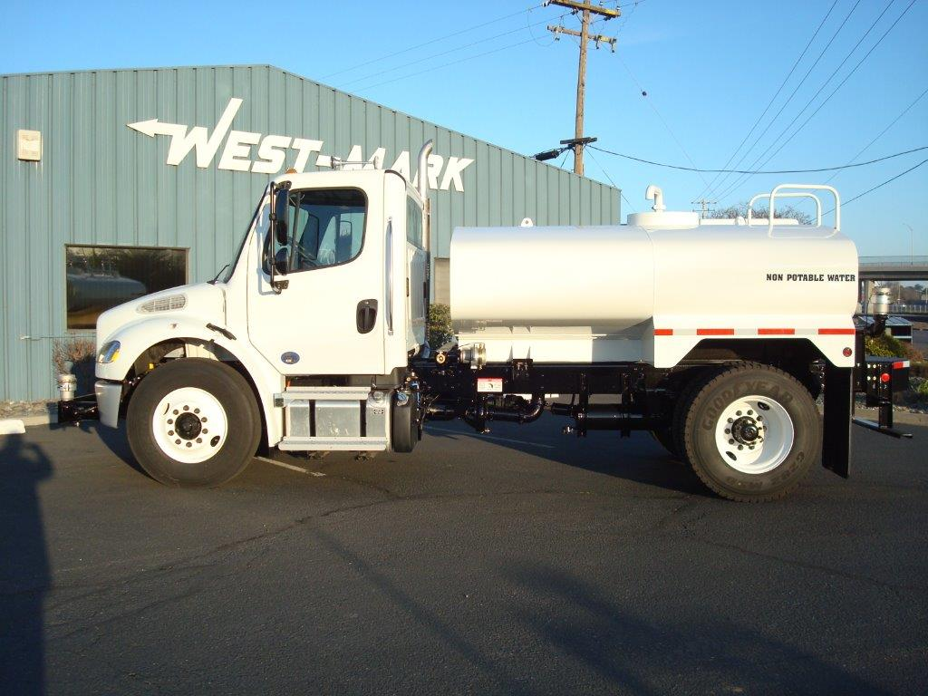

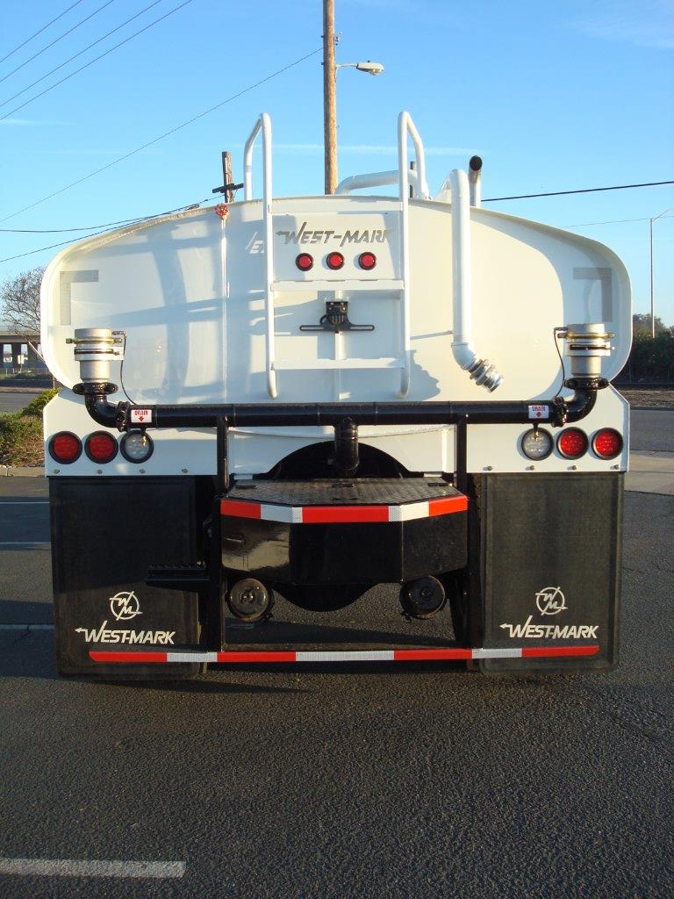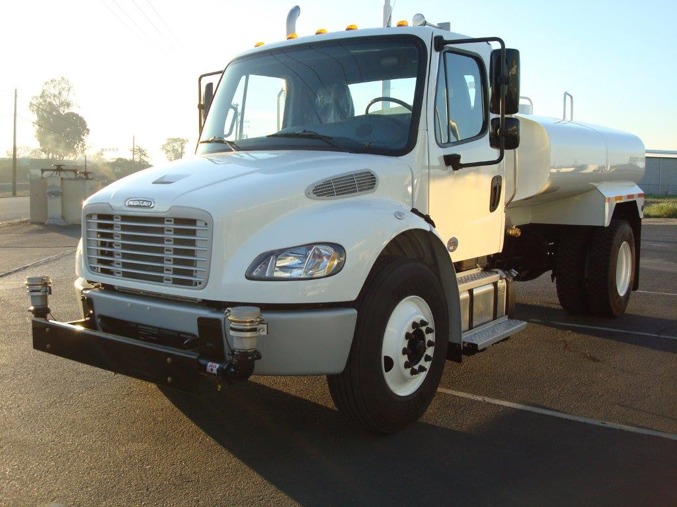

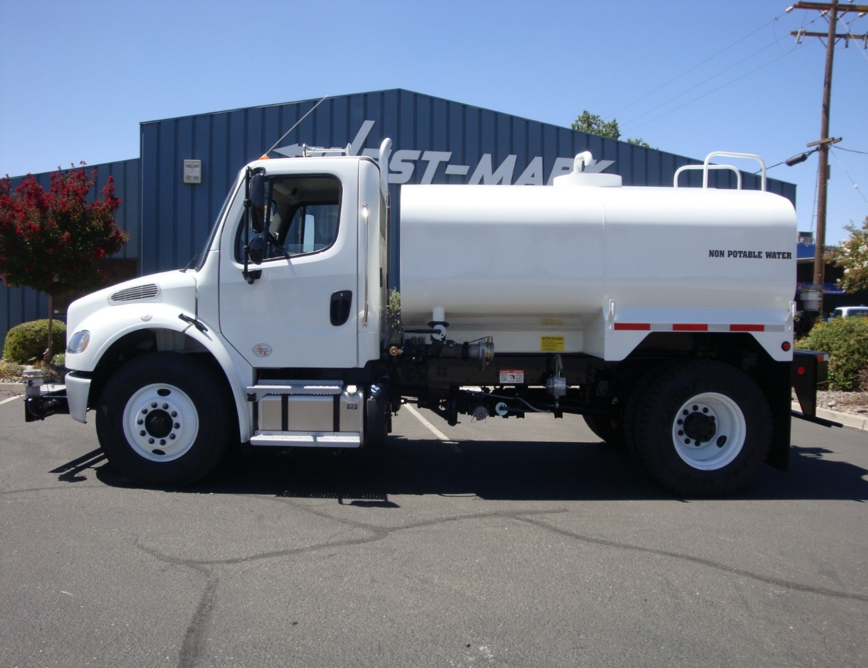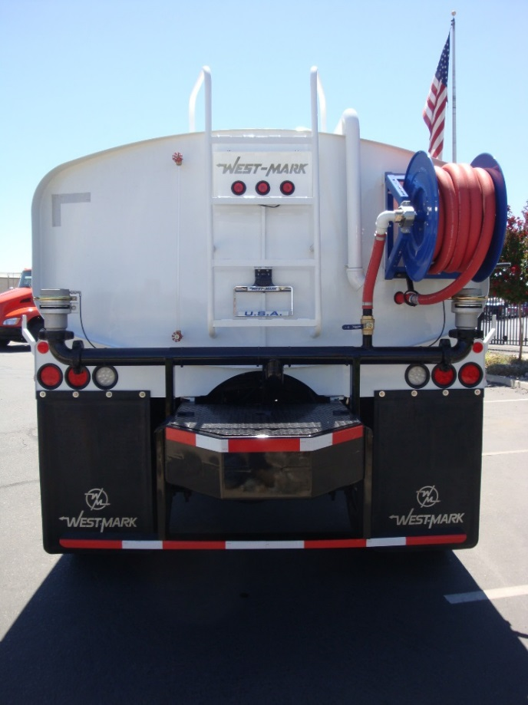

**DUST CONTROL TRUCK (2-AXLE, CARBON STEEL)**

**WATER2ATTC**

**Key Features and Enhancements:**

**Chassis: Conventional 2 door cab**

**(various brands)**

**Front Axle: Various ratings/ front drive available**

**Rear Axle: Single w/ various ratings**

**Suspension: Spring; w/ air upon request**

**Engine: Various HP and torque ratings**

**Transmission: Various manual and automatic**

**Fuel Capacity: 50 Gal w/ larger sizes available**

**Tires: Highway or mud and snow available**

**Tank Size: 1500 - 2000 Gallons**

**Tank Shape: Oval or rectangular oval**

**Tanks Material: 3/16’’ carbon steel w/ 1/4’’ option**

**Baffles: Many options available**

**Manhole: 24’’ open top std (many options available)**

**Ladder: Various styles and locations available**

**Lights and Wiring: LED per DOT specifications**

**Fenders: Various configurations available**

**Water Pump: PTO, hydraulic or pony driven**

**Pump Performance: 350 to 1250 gpm**

**Rear Bumper: Various styles available**

**Hose Reel: Available in air, spring or electric rewind**

**Monitor: Available in various locations**

**Rear Spray bar with multiple discharges available**

**Front Spray bar with multiple discharges available**

**Side sprays available with manual or electric pivot**

**Suction hose storage and suction hoses available**

**Various cabinets in multiple configurations available**

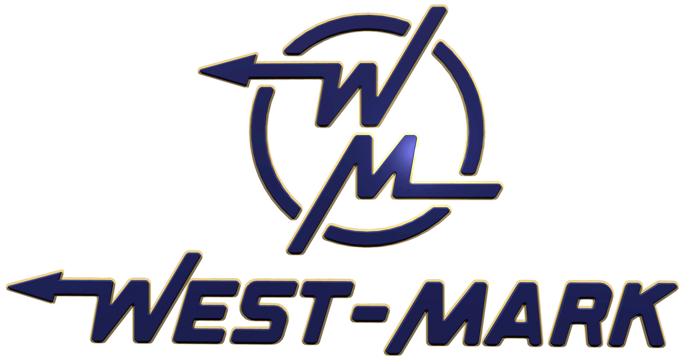

**P.O. Box 100 2704 Railroad Avenue Ceres, CA 95307**

**(209) 537-4747 (800) 692-5844**

**Fax (209) 537-1753**

**www.west-mark.com**

**Brochure may reflect certain Enhancements or Features not published or included in the base Model configuration.**