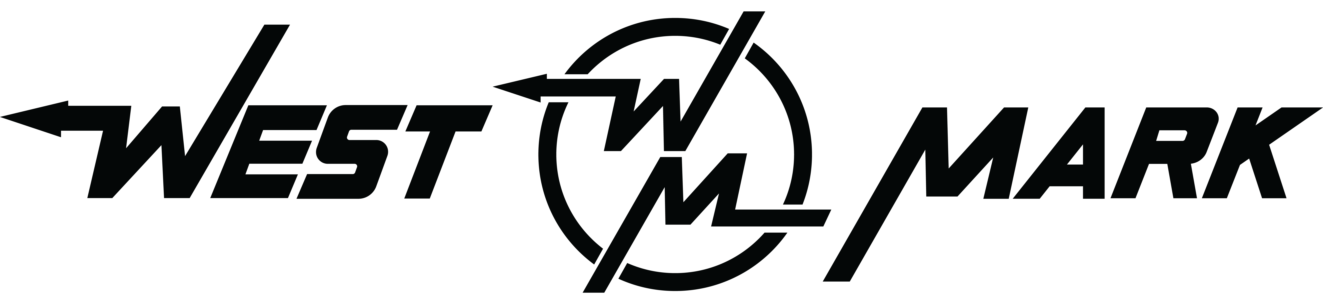

DLA Contract SPE8EC-18-D-0006/SPE8EC-21-F-1100

CLIN 0005 Training DODAAC W90P89 ANNVILLE, PA

COURSE TITLE: 60 Ton Kaufman Trailer Training

Start Date: 9/15/22 Full operational training platform – Custom Landing page
The custom landing page resource center is designed to provide ongoing training and repository for all documents pertaining to the equipment being provided. This will provide new servicemen and women access to all resources and updates when needed.

- Full Operational Training Video
- Operations Manual
- Engineers Drawing
- Wiring Schematics
- 24 Hour communication (will respond in one business day)

Authority: The Government Employee Training Act of 1958 (USC Title 5, 4101 to 4118), EO 9397, November 1943 (SSN)
Purpose and Use: The purpose of this form is to document the nomination of trainees and completion of training; it also serves as the principal repository of personal, fiscal and administrative information about trainees and the program in which they participate. The form becomes a part of the permanent employment record of participation in training programs and is included in the Government’s Central Personnel Data File.
Disclosure: Personal information provided on this form is given on a voluntary basis. Failure to provide this information, however, may result in ineligibility for participation in training programs.

Instructors Signature:  _Date:_____________________

Training for trailers purchased under the Delivery Order mentioned above has been provided to the satisfaction of the end user.

POC Signature:_________________________________________Date:_____________________

